KLASIFIKASI DENGAN BAHASA R

DATASET = CO2 (eksperimen kadar dingin dari spesies jenis rumput *Echinochloa crusgalli*)

OVA SAGITA (14.01.53.0052)

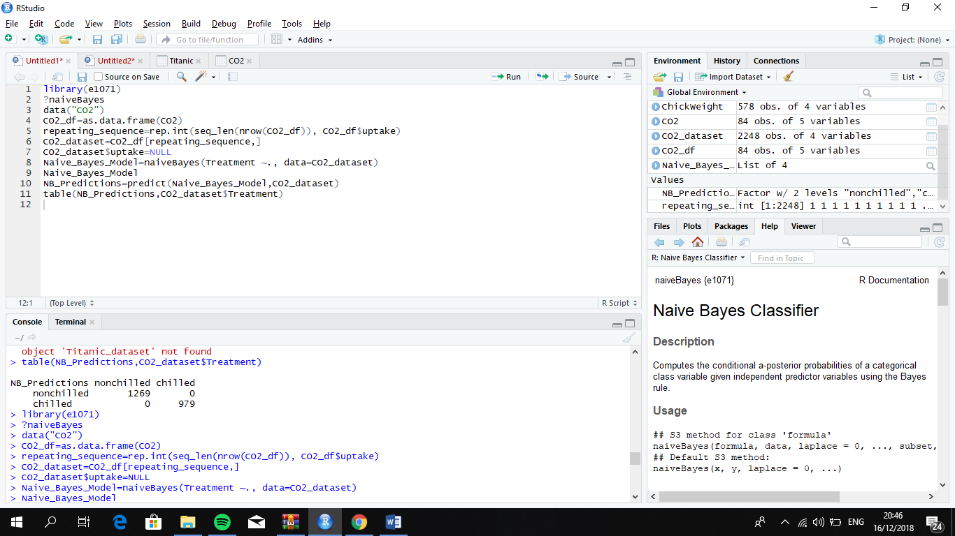

library(e1071)

?naiveBayes

data("CO2")

CO2_df=as.data.frame(CO2)

repeating_sequence=rep.int(seq_len(nrow(CO2_df)), CO2_df$uptake)

CO2_dataset=CO2_df[repeating_sequence,]

CO2_dataset$uptake=NULL

Naive_Bayes_Model=naiveBayes(Treatment ~., data=CO2_dataset)

Naive_Bayes_Model

NB_Predictions=predict(Naive_Bayes_Model,CO2_dataset)

table(NB_Predictions,CO2_dataset$Treatment)

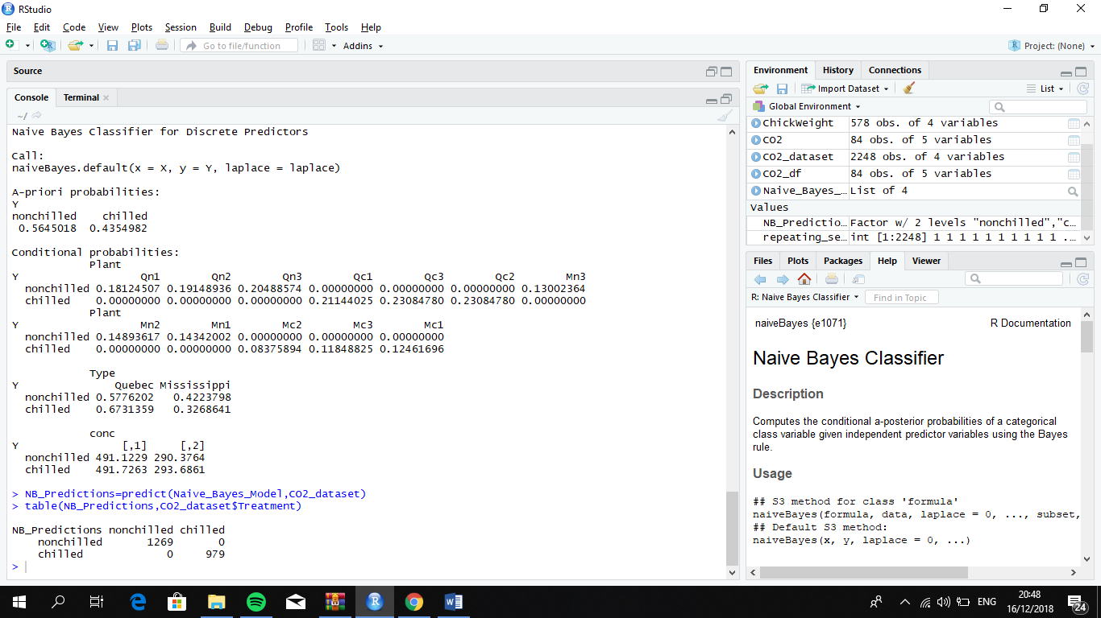

Naive Bayes Classifier for Discrete Predictors

Call:

naiveBayes.default(x = X, y = Y, laplace = laplace)

A-priori probabilities:

Y

nonchilled chilled

0.5645018 0.4354982

Conditional probabilities:

Plant

Y Qn1 Qn2 Qn3 Qc1 Qc3 Qc2 Mn3

nonchilled 0.18124507 0.19148936 0.20488574 0.00000000 0.00000000 0.00000000 0.13002364

chilled 0.00000000 0.00000000 0.00000000 0.21144025 0.23084780 0.23084780 0.00000000

Plant

Y Mn2 Mn1 Mc2 Mc3 Mc1

nonchilled 0.14893617 0.14342002 0.00000000 0.00000000 0.00000000

chilled 0.00000000 0.00000000 0.08375894 0.11848825 0.12461696

Type

Y Quebec Mississippi

nonchilled 0.5776202 0.4223798

chilled 0.6731359 0.3268641

conc

Y [,1] [,2]

nonchilled 491.1229 290.3764

chilled 491.7263 293.6861

|  |
| --- |
| > NB_Predictions=predict(Naive_Bayes_Model,CO2_dataset)  > table(NB_Predictions,CO2_dataset$Treatment)    NB_Predictions nonchilled chilled  nonchilled 1269 0  chilled 0 979 |
|  |
| |  | | --- | | > | |